Position Mixture
Send Feedback

The 3 boxes with the position value set are shown on web page as:
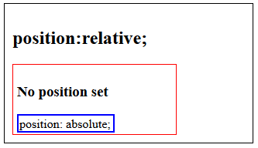

If the property “top: 0;” is added to element with blue border, then how will it be shown on the web page?

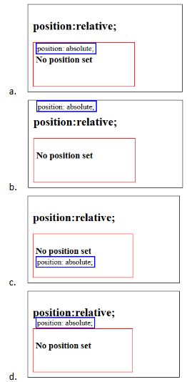

Ans: b

